Call <http://localhost:63306/api/generatepdf>

Through browser

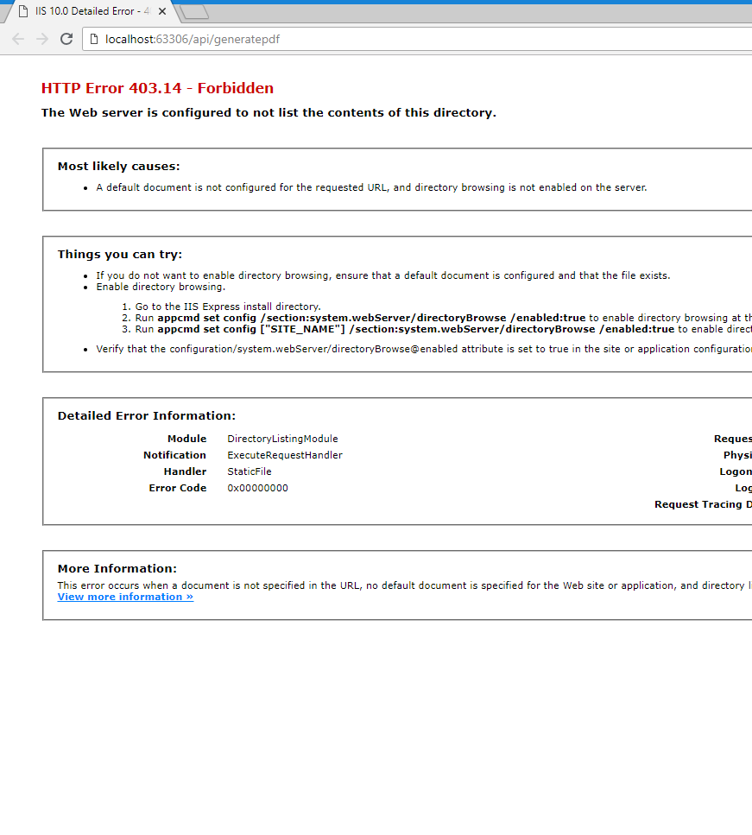

This will download a PDF

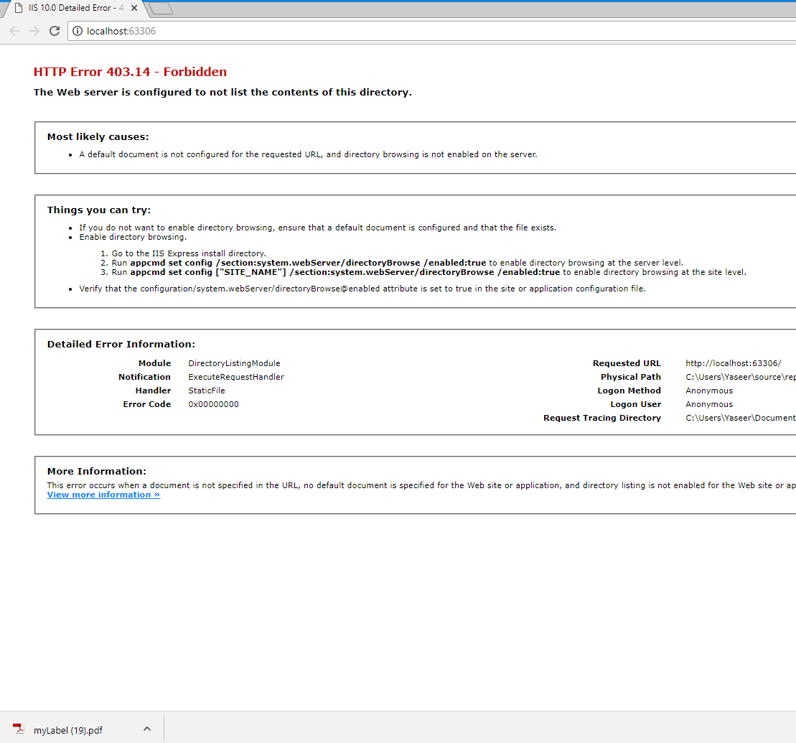

Through Fiddler

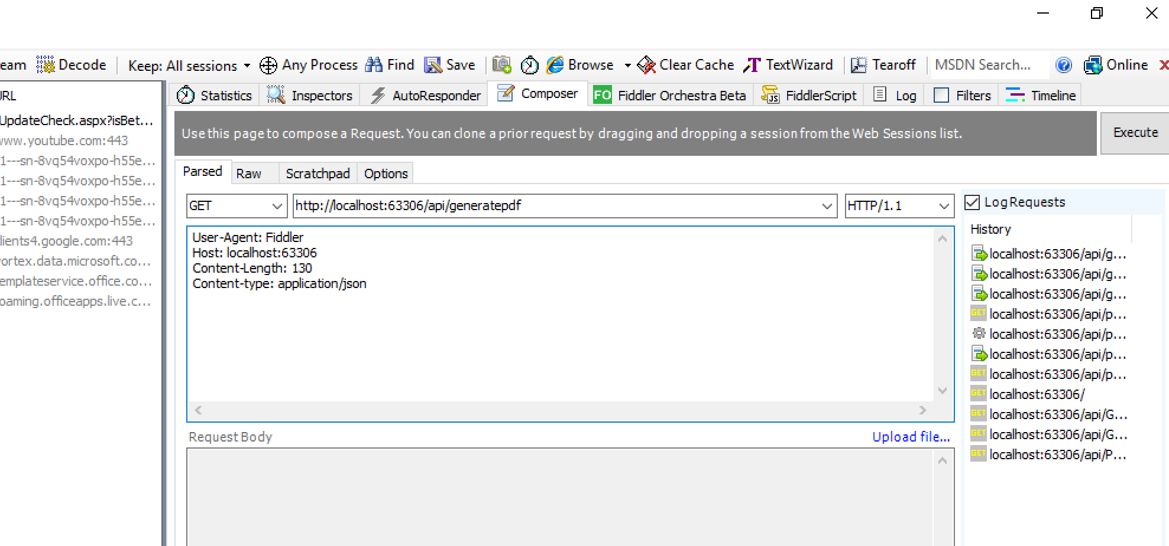

After Execute

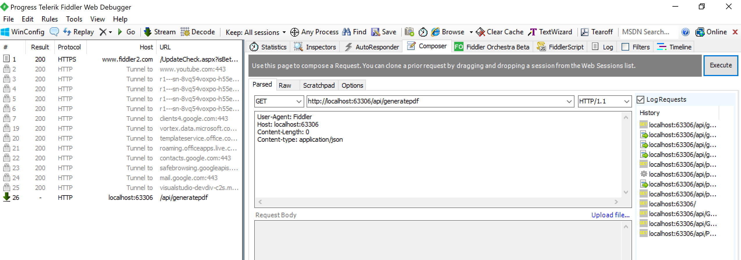

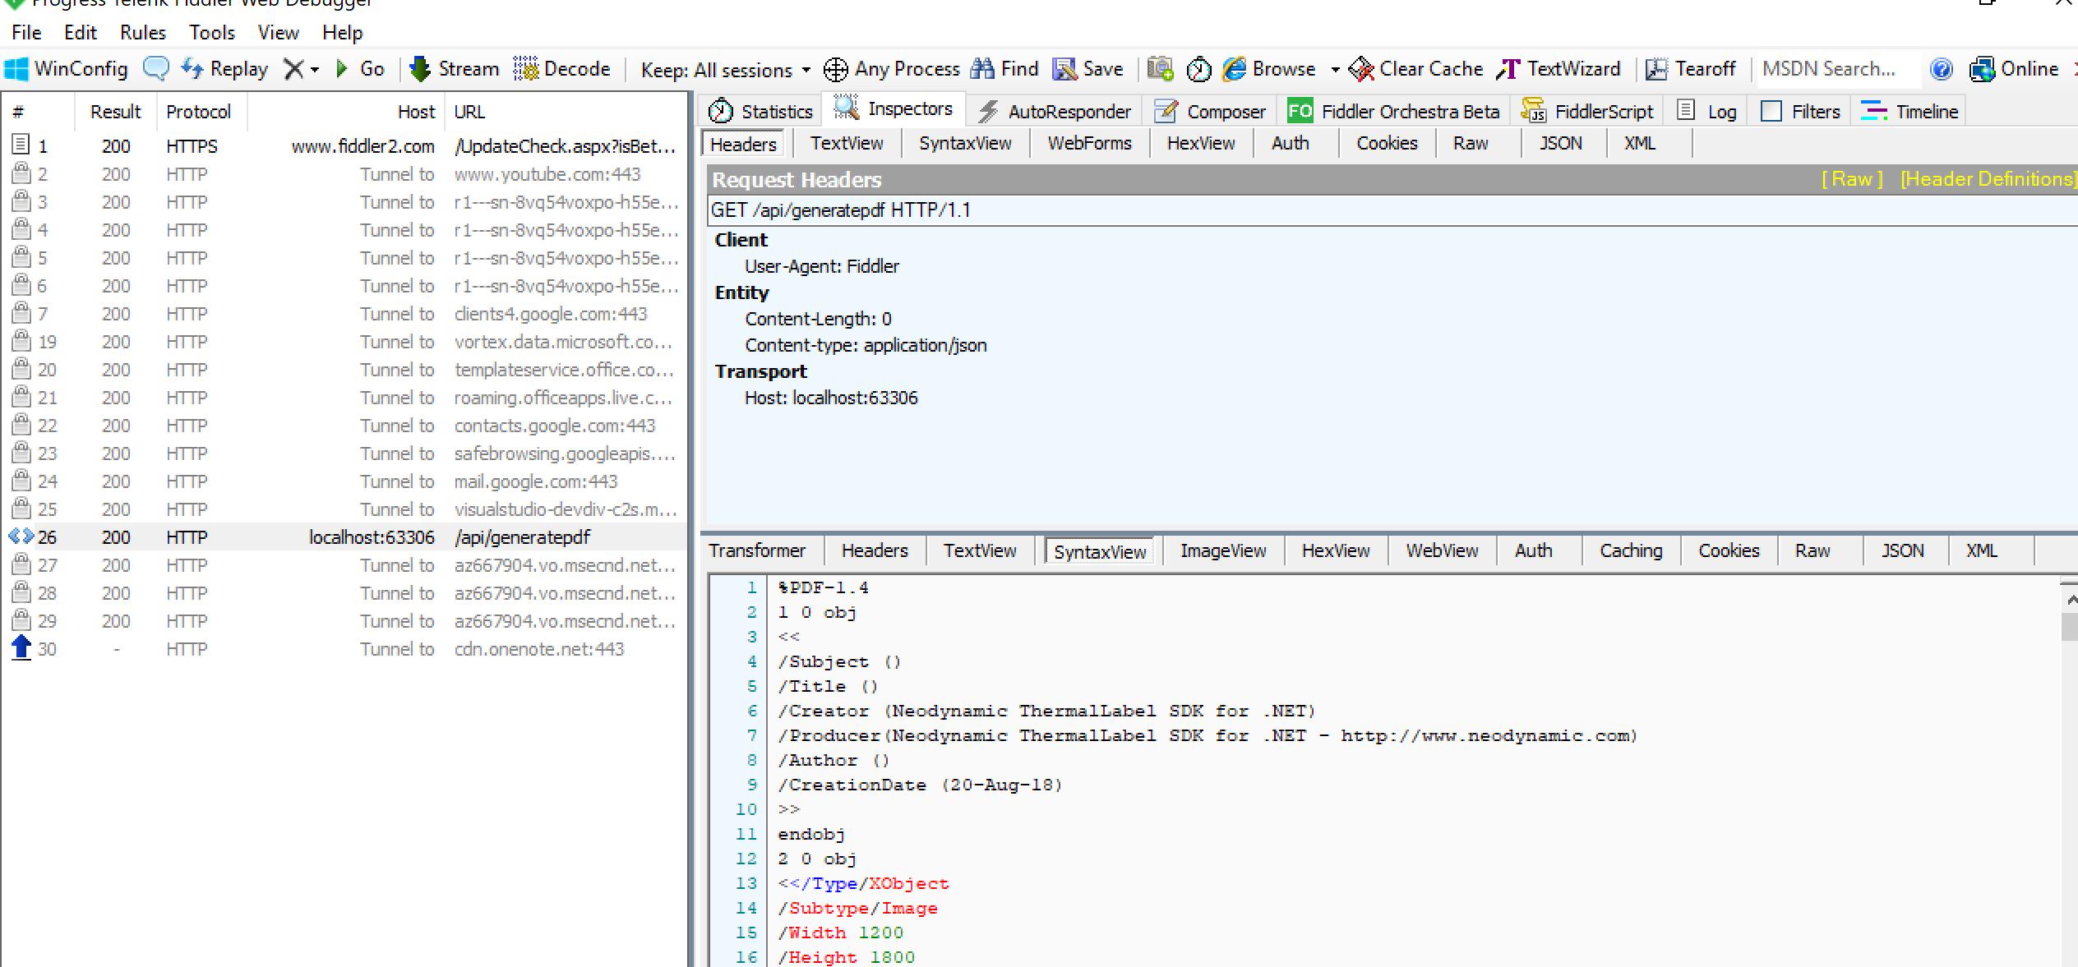

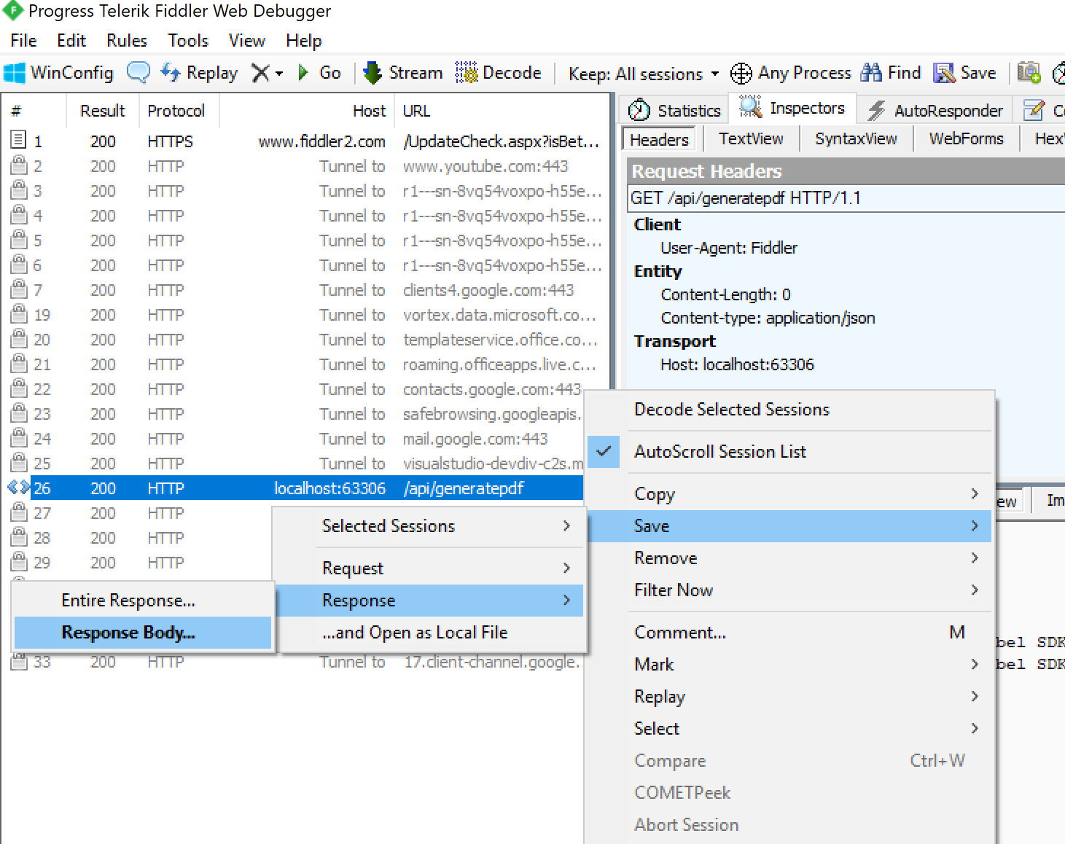



Follow these steps:

* Open the .Net project given in Visual Studio
* Run in chrome which runs using IIS Express
* Call this API (GET) from your front end application

Note

* This is only a sample version

Consuming a POST API

As the UI need to pass numerous values to this API, A PUT API is designed, UI can access the PUT action in this API by passing the required fields as below in the body of the request

Request:

Make sure PUT action is selected

|  |
| --- |
| Content-type: application/json |

Request body

|  |
| --- |
| {"OrderNumber":"",  "Sender":"",  "InvoiceNumber":"Oscar1",  "DelName":"Oscar",  "Deladdr1": "12 Pitt Street",  "Deladdr2": "Darwin NT 800",  "Deladdr3": "Darwin",  "Deladdr4": "NT",  "Postcode": "800",  "Delpost": "",  "ShipperName1": "DWA",  "ShipperCity": "",  "LabelColor": "",  "ArticleId": "6RX900236501082000800",  "Connote2": "6RX9002365",  "BarcodeLabelNumber":"997001936RX900236501082000800",  "LabelSequence":"1 OF 1",  "RFCode":"",  "QRCodes":"~1019931265099999891ZK610182660100093510642020008008180415120000",  "BarcodeLabelNumberd":"997001936RX900236501082000800D",  "TodaysDate":"25/08/2018"  } |

